**SPRINT 4 PLAN**

Project Name: Boba Tracker

Team Name: Boba Peeps

**GOALS:**

Our goal is to make the UI more visually appealing, allowing users to edit their entries and view the sugar chart in their dashboard.

**TASKS**

User story 1: As a user, I want to view the sugar content in a chart. (5 Story Points)

* Add a sugar chart.
  + Time estimate 2 hour
* Change chart data to be weekly.
  + Time estimate 2 hours

User story 2: As a user I want to be able to edit previous entries in case I make a mistake (8 Story Points)

* Add edit drink feature.
  + Time estimate: 3 hours

User story 3: As a developer, I want an attractive, well organized layout that will motivate users to use the app. (5 Story Points)

* Change UI for history page
  + Time estimate: 1 hour
* Change UI for login and create an account page
  + Time estimate: 1 hour
* Change UI for new drink form page.
  + Time estimate: 1 hour
* Change UI for editing drink page.
  + Time estimate: 1 hour

**TEAM ROLES**

* Jarod Alvarez: Product Owner
* Maggie Lee: Developer
* Johana Martinez: Developer
* Thai Nguyen: Developer
* Chi Huynh: Scrum Master

**INITIAL TASK ASSIGNMENT**

* Jarod Alvarez
  + User story: 1
  + Initial Task: Add a sugar chart.
* Maggie Lee
  + User story: 1
  + Initial Task: Change chart data to be weekly.
* Johana Martinez
  + User story: 3
  + Initial Task: Change UI for login and register page and change UI for new drink page.
* Thai Nguyen
  + User story: 3
  + Initial Task: Change UI for history page.
* Chi Huynh
  + User story: 2 and 3
  + Initial Task: Add edit drink feature and change UI for editing drink page.

**INITIAL SCRUM BOARD**

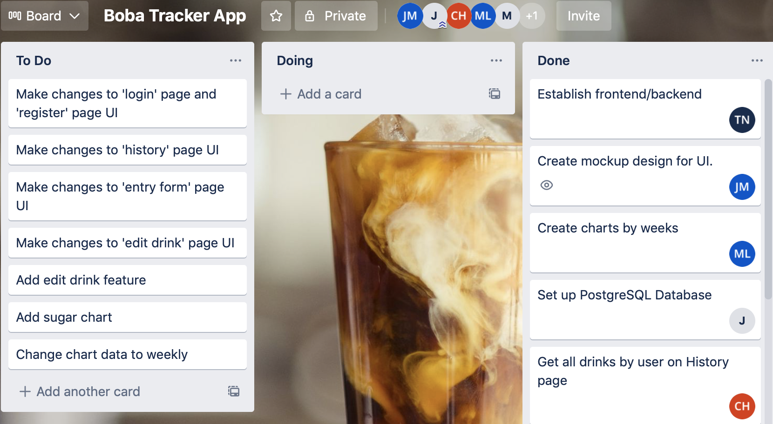

**BURNUP CHART**

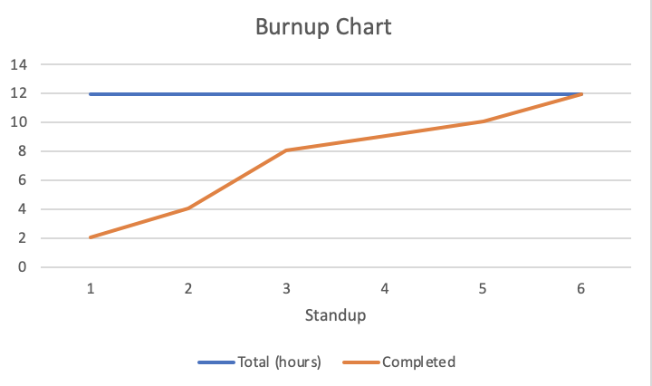

**SCRUM TIMES**

* **MWF - 7pm PST** (Team Stand Up)
* **Wed - 10:30 PST** (Weekly TA Stand Up)